**INTERVIEW QUESTION ASSIGNMENT**

**—------------------------------------------------------------------------------------------------------------------**

1. **What is difference between truncate,delete and drop**
2. **Truncate:**
3. Truncate is used for deleting structure
4. We can not use where clause with truncate
5. Truncate is not row oriented function and we can roll back it
6. **Delete:**
7. Delete is row oriented command which can be rollback
8. With delete we can use where clause

1. **Drop:**
2. Drop is table related command
3. It cannot be roll back
4. **What are aliases in MySql?**

Alias is temporary name given to the table or column of table

Note: I am My table called Marksheet

1. **How do you display even rows of any table?**

**select * from marks where prn % 2 = 0;**

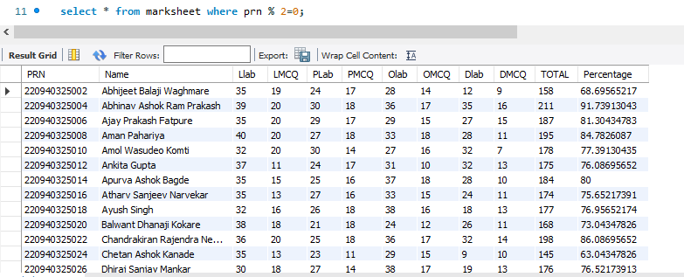

select * from (select name, row_number() over(order by percentage desc) as row_numbers from marksheet) as temp where row_numbers % 2=0;

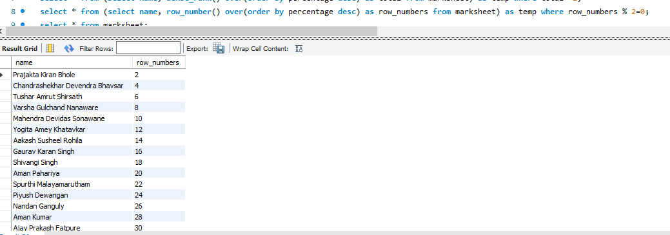

1. **How can you remove duplicates from table**

select distinct(total) from marksheet;

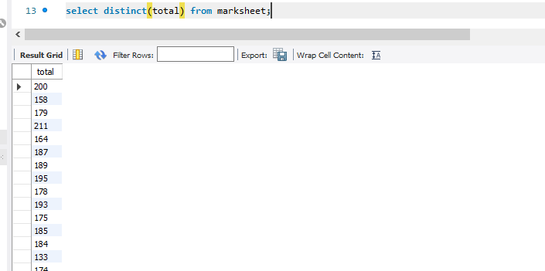

select name, row_number() over(order by total desc )as rowno from marksheet; //by assigning row number to each column

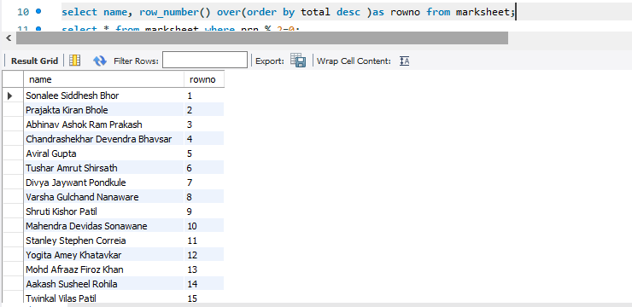

1. **How can you find 5th max total?**

select name,total from marksheet order by total desc limit 5,1;

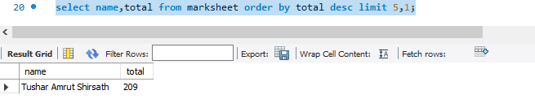

select * from (select name, dense_rank() over(order by percentage desc) as total from marksheet) as temp where total =5;

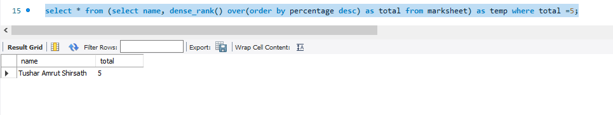

select * from marksheet m1 where 4 = (select count(distinct total) from marksheet m2 where m2.total>m1.total);

